GENBN401– BASICS OF NETWORKING

DATE: Monday, 16 June 2025
PERIOD: 8.30 AM-11.30 AM


END OF TERM III EXAMINATIONS SCHOOL YEAR: 2024/2025
KIREHE ADVENTIST TVET SCHOOL(APAPEN)
SECTOR: ICT and MULTIMEDIA RQF LEVEL: L4
TRADE: SOFTWARE DEVELOPMENT MARKS: CAMIS:
…………/100
…………/70

DURATION: 3 HOURS

INSTRUCTIONS TO CANDIDATES:
This Exam paper is composed of Three Sections (A, B, C). Follow the instructions given below, and answer the indicated questions for a
total of 100 marks
Section A: Seventeen (17) questions, all Compulsory
55 marks
Section B: Among the five (5) questions, attempt any three (3) 30 marks
Section C: Among the two (2) questions, attempt any one (1)
15 marks
Allowed materials:
- Ruler ,Blue or Black pen

Level 4 GENBN401– Basics Of Networking – Page 1 of 20 –Marking guide

SECTION A: Attempt all questions (55 marks)
KIREHE ADVENTIST TVET SCHOOL(APAPEN)

01. | Read carefully and choose correct statements that describe the definition of “computer network is:  - A collection of hardware components and computers interconnected by communication channels that aren’t allow sharing of resources and information.  - A network Architecture in which each computer on the network is either a client or a server network.  - A Powerful computer that provides services to other computers on the network.  - A group of computers connected with each other to communicate and share information and resources like hardware, data, and software. | (2marks)
02. | Choose the correct answer from the following listed alternatives.  - A network is……………  - One or more computer connected for sharing resources  - Two or more computer connected for sharing resources  - A series of telephone lines  - What is the key benefit of using a network?  - Sharing information and resources  - It is cheap  - Security | (4marks)

Level 4 GENBN401– Basics Of Networking – Page 2 of 20 –Marking guide

03. | Choose the best standard for IP Address from the flowing standard?  - Internet protocol address  - Ethernet protocol address  - Intranet protocol address  - Internet property address | (2marks)
04. | Select the Type of IP Addresses from the following options:  A. Prevalent  B. Public  C. Internet  D. protocol | (2marks)
05. | Differentiate between Internet Protocol (IP) and Domain Name in a network and give one example for each? | (4marks)
KIREHE ADVENTIST TVET SCHOOL(APAPEN)
Level 4 GENBN401– Basics Of Networking – Page 3 of 20 –Marking guide

06. | Which of the following is a type of maintenance that will involve in repairing or replacing a damaged network cable?  - Preventive maintenance  - Corrective maintenance  C. Software maintenance  D. Firmware maintenance | (3marks)
KIREHE ADVENTIST TVET SCHOOL(APAPEN)
Level 4 GENBN401– Basics Of Networking – Page 4 of 20 –Marking guide

07. | Which of the following is the main purpose of upgrading network monitoring software?  - To fix bugs and enhance security  - To clean physical devices  - To change device passwords  - To configure new network adapter | (3marks)
08. | From the listed Networking hardware and network Infrastructure corrective in network devices maintenance, separate them in their respective column. | (4marks)
KIREHE ADVENTIST TVET SCHOOL(APAPEN)

Networking hardware and  network Infrastructure | Networking  hardware | network  Infrastructure
- Firewall and Gateway
- Coaxial cable
- Switch
- Fiber-optic cable
- Access Point
- Ethernet cables
- Router
- Antenna Wi-Fi

09. | After understanding IP Address Classification, answer the questions bellow:  - Which of the following is the primary function of an IP address?  - To store data packets  - To identify a device and enable communication over a network  - To encrypt data over the network  - To assign internet speed to a device  - Which of the following IP address types is assigned by an ISP for temporary use and can change over time?  - Static IP address  - Private IP address  - Dynamic IP address  - Public IP address | (4marks)
KIREHE ADVENTIST TVET SCHOOL(APAPEN)

Level 4 GENBN401– Basics Of Networking – Page 6 of 20 –Marking guide

10. | After Understanding IP Versions, provide the answer of the following questions:  - Which of the following is a feature of IPv4?  - 128-bit addressing scheme  - Supports a larger number of unique IP addresses than IPv6  - Uses hexadecimal notation for IP addresses  - Creates 32-bit IP addresses  - Which version of IP uses a 128-bit hexadecimal addressing scheme?  - IPv1  - IPv4  - IPv6  - IPv3 | (4marks)
11. | Which of the following should you do if the network card is detected as an "Other device" in Windows Device Manager?  - Restart the computer and try again  - Download the latest drivers for the network card  - Replace the network card  - Check the router’s configuration | (3marks)
KIREHE ADVENTIST TVET SCHOOL(APAPEN)
Level 4 GENBN401– Basics Of Networking – Page 7 of 20 –Marking guide

12. | What is the major purpose of making recommendations in a network maintenance report?  - To highlight the network's weaknesses  - To suggest improvements or enhancements for future maintenance  - To critique the network administrator's performance  - To focus on hardware replacement | (3marks)
13. | Which of the following is used to prevent signals from bouncing back on a coaxial cable?  A. T-type connector  B. Terminator connector  C. BNC barrel connector  D. F connector | (3marks)
14. | Classify the IP addresses below based on their range and name of classes. Those IP address are:  - 192.168.112.99  - 32.110.21.18  c. 168.168.168.99  d. 223.118.99.88. | (4marks)
KIREHE ADVENTIST TVET SCHOOL(APAPEN)
Level 4 GENBN401– Basics Of Networking – Page 8 of 20 –Marking guide

15. | Which of the following steps correctly leads you to configure a network adapter to use a dynamic IP address (DHCP) through the Control Panel?  - Open Control Panel, > click on Network Center, > select "Change adapter settings, > click on property, > Connect internet."  - Open Control Panel, > click on Network and Internet, > choose "Network and Sharing Center", > Go to the property, > shared internet.  - Open Control Panel, > click on Network and Sharing Center, > click "Change adapter settings."  - Open Control Panel, > click on Network and Internet, > connect to the internet, > view network status. | (3marks)
KIREHE ADVENTIST TVET SCHOOL(APAPEN)

Level 4 GENBN401– Basics Of Networking – Page 9 of 20 –Marking guide

16. | By using a table, classify the following IP addresses into their appropriate network classes (class A, class B, class C, class D). Those IP addresses are: 225.1.0.2, 100.30.70.9, 230.10.23.2,  10.10.10.10, 130.1.0.100, 200.4.6.2, 172.16.0.10, 193.200.4.9 | (4marks)
17. | Which of the following steps are necessary to set a static IP address in Windows 10 or 11?  - Open the Start Menu > Control Panel > Network and Sharing Center > Change adapter settings.  - Right-click on Wi-Fi > Local Area Connection > select Properties>Contral panel>View network status>Task.  - Select Internet Protocol >Version 4 (TCP/IPv4)>click  Properties>View network and internet.  D. Select "Use the following IP address" >enter the necessary IP address> Subnet mask>Default gateway. | (3marks)
KIREHE ADVENTIST TVET SCHOOL(APAPEN)
Level 4 GENBN401– Basics Of Networking – Page 10 of 20 –Marking guide

Section B: Attempt any three (3) questions (30 marks)
KIREHE ADVENTIST TVET SCHOOL(APAPEN)
KIREHE ADVENTIST TVET SCHOOL(APAPEN)

18. | Match these types of networks with their roles in networking (Write role number in the Answer column)  Type of Roles Answer  network  - WAN A. It is a small-scale network that revolves ……. around one person or device. It  connects just a few devices in a small localized area.  - GAN B. It is designed to connect multiple …… network devices and systems within a  limited geographical distance.  - MAN C. It is a network type that covers the ……. network connection of an entire city or connection of a small area.  - PAN D. It is designed to connect devices over …….. large distances like states or between countries. The connection is wireless in  most cases and uses radio towers for communication.  - LAN E. It is network that covers a global or ……. international scale, often using satellite  links and undersea cables. | (10marks)

Level 4 GENBN401– Basics Of Networking – Page 12 of 20 –Marking guide

19. | Given the IP address 192.168.2.143/22, Answer the following | (10marks)
 | questions:
 | A. Identify the class of this IP address.
 | B. Determine the network ID and host ID for this IP address.
 | C. What is the subnet mask associated with this network?
 | D. How many bits are used for the network portion?
 | E. How many hosts can be accommodated within this network?
KIREHE ADVENTIST TVET SCHOOL(APAPEN)
Level 4 GENBN401– Basics Of Networking – Page 13 of 20 –Marking guide

20. | Network media is the physical path through which data travels from one device to another in a network. It can be a wire (like a cable), Network cables include RJ45 cables, Coaxial Cables among others.  - Identifying the necessary materials for making RJ45 cable  - Develop a step-by-step guide on how to make an RJ45 cable | (10marks)
KIREHE ADVENTIST TVET SCHOOL(APAPEN)

Level 4 GENBN401– Basics Of Networking – Page 14 of 20 –Marking guide
KIREHE ADVENTIST TVET SCHOOL(APAPEN)
21. | Consider the window below that was derived after running an IPCONFIG command in a laboratory, Evaluate the significance and implications of the information displayed and answer related sub questions  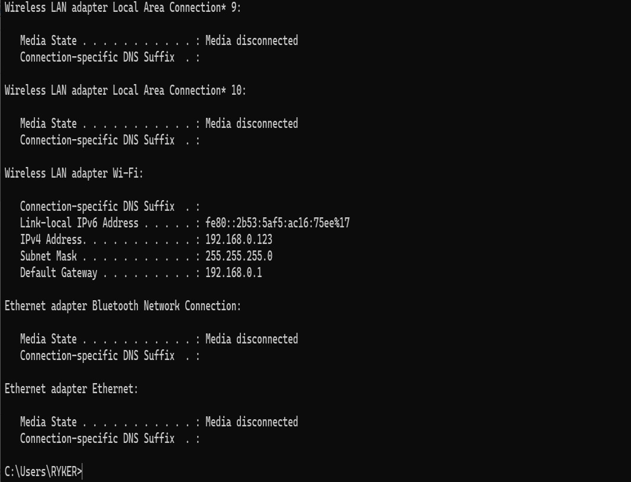  - Which IP Version 4 address this computer is connected to?  - In which class it belongs to?  - What is its subnet mask?  - Which IPv6 that this WLAN adapter is using  - What is its default gateway?  - How many bits which specify IPv4 and IPv6 addresses? | (10marks)
KIREHE ADVENTIST TVET SCHOOL(APAPEN)
Level 4 GENBN401– Basics Of Networking – Page 16 of 20 –Marking guide

22. | Subnetting is the process of dividing a larger network (IP address block) into smaller, more manageable pieces called subnets. Differentiate between Fixed Length Subnet Masking (FLSM) and Variable Length Subnet Masking (VLSM). | (10marks)
KIREHE ADVENTIST TVET SCHOOL(APAPEN)

Level 4 GENBN401– Basics Of Networking – Page 17 of 20 –Marking guide

Section C: Attempt only one (1) question (15 marks)
KIREHE ADVENTIST TVET SCHOOL(APAPEN)

23. | You’ve been assigned to set up a network for a small business. To build an efficient, reliable, and scalable system, which five physical network topologies would you consider for connecting devices like computers, printers, and servers?  For each topology:  A. Explain how it works.  B. Provide a simple diagram to illustrate the connection setup. | (15marks)

Level 4 GENBN401– Basics Of Networking – Page 18 of 20 –Marking guide

24. | IP address assignment is the process of allocating unique Internet Protocol (IP) addresses to devices on a network so they can communicate with each other and access the internet or internal  services. To allocate IP addresses effectively, you need to complete a | (15marks)
KIREHE ADVENTIST TVET SCHOOL(APAPEN)
Level 4 GENBN401– Basics Of Networking – Page 19 of 20 –Marking guide

table below that outlines important details for the three primary IP address classes (Class A, Class B, Class C). For each class, provide:

- The First Network ID
- The Last Network ID
- The Default Subnet Mask
- Identify which class would be most appropriate for large, medium, and small network environments.
Use this table format to complete your responses:
KIREHE ADVENTIST TVET SCHOOL(APAPEN)

CLASS | First  Network ID | Last  Network ID | Default  Subnet mask | Typical  Use Case
Class A | ? | ? | ? | ?
Class B | ? | ? | ? | ?
Class C | ? | ? | ? | ?

